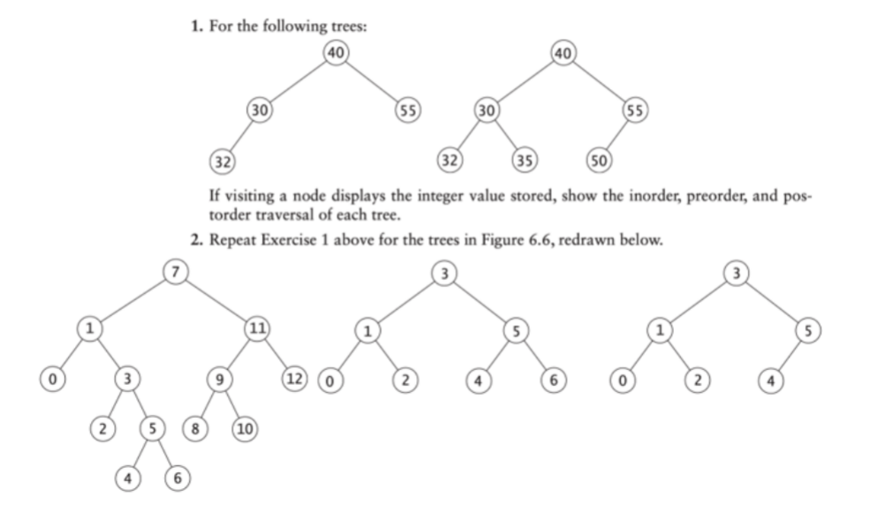

1)

Inorder (L, root, R)  
1. 32 30 40 55

2. 32 30 35 40 50 55

Preorder (root, L, R)  
1. 40 30 32 55

2. 40 30 55 32 35 50

Postorder (L, R, root)

1. 32 30 55 40

2. 32 35 30 50 55 40

2)

Inorder (L, root, R)  
 1. 0 1 2 3 4 5 6 7 8 9 10 11 12

2. 0 1 2 3 4 5 6

3. 0 1 2 3 4 5

Preorder (root, L, R)  
1. 7 1 0 3 2 5 4 6 11 9 8 10 12

2. 3 1 0 2 5 4 6

3. 3 1 0 2 5 4

Postorder (L, R, root)

1. 0 4 6 5 2 3 1 8 10 9 12 11 7

2. 0 2 1 4 6 5 3

3. 0 2 1 4 5 3

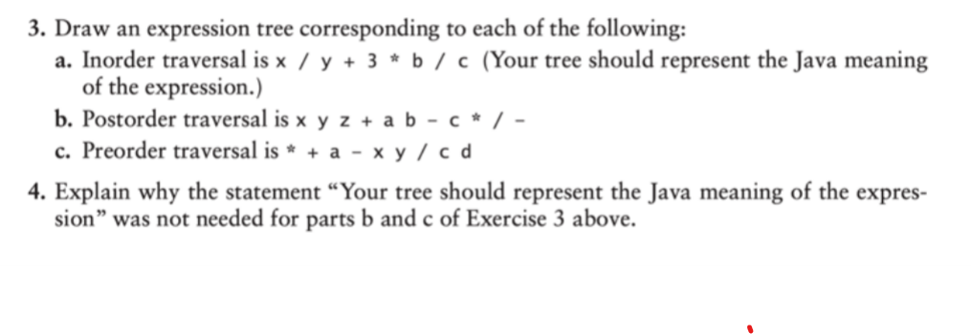

1. Inorder Traversal:
2. Postorder Traversal:
3. Preorder Traversal:

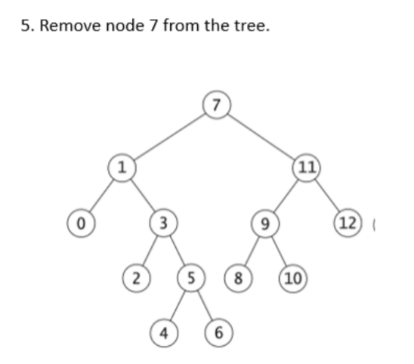

Left < root < Right

6 or 8 can replace 7